LS-DYNA Crash Tutorial 1 Page 1 of 13

PRE AND POST-PROCESS CASE STUDY

SIMPLE CRASH TEST PRE AND

POST-PROCESSING

The objective of this case study is to pre and post-processing a simple LS-
DYNA Crash test. The analysis is carried out in nine steps:

•

•

•

•

•

•

•

•

•

GiD-LSDYNA installation

General data definition

Part definition

Constraints definition

Initial conditions definition

Postprocessing options selection

Model Meshing

Simulation run

Results viewing
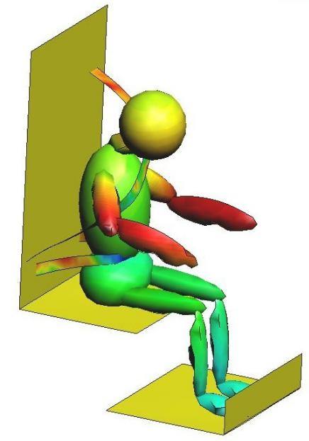

Figure 1. Problem overview

LS-DYNA Crash Tutorial 1 Page 2 of 13

1. GID-LSDYNA INSTALLATION

At the moment, GiD-LSDYNA interface is only available in Windows OS. Follow these instructions to install it:

  - Install GiD Software on your computer

  - Run GiD software (from your program menu or from the created desktop icon).

  - Enter your license key or select it from a specific path (only if license alert appears)

  - Install lsdyna interface from Internet Retrieve section (Data menu). Lsdyna will be ticked in available problemtypes list (Data->Problem type of GiD menu). If not, please select it.

  - By default, the interface menu (a data tree showing created groups and problem data) should appear on the left of your screen. If you can't see it, please click (Data->Data(internal) of GiD menu).

- GENERAL DATA DEFINITION

You can also find the model of this case in the Internet Retrieve section. It should be installed in your GiD Examples folder (for instance C:/Program Files/GiD/Gid lsdyna 1.1b/Examples). The model is named gid_lsdyna_tutorial.gid .

- Open our case. Files->Open of GiD menu and select gid_lsdyna_tutorial.gid path

- Choose Render→Flat from the mouse menu if this option is not selected (right click on screen)

- Choose Rotate→Trackball from the mouse menu (this tool is also available by pressing ALT key+ left click ). Make a few changes to the perspective in order to get an idea of the geometry under study

- Edit General Data information in the interface menu:

  - In Units menu, set Mesh Units to cm (to represent human being sizes)

  - In Gravity menu, activate gravity and set its value to 9,81 m/s² (in X+ sense)
LS-DYNA Crash Tutorial 1 Page 3 of 13

3. In Solver menu, set End time to 0.01 s

- PART DEFINITION

  - GiD-LSDYNA Interface is based in group concept. A group is a group of geometrical entities or mesh elements where one or several conditions are applied. These conditions could define geometrical properties and materials, loads, constraints, etc. Property groups are very important in this case, because in LS-DYNA every element must be related with a material (it means that in our interface each geometrical entity should be related with a single property group).

  - Most of problem parts are already defined as groups. You can notice it by drawing shell parts. Please right click Properties->Shells in the interface menu. Select Draw-Groups option.

  - First we must define materials. By default, one material sample of each type has been created. More materials could be created (right click in a material type) and modified with the interface (Figure 2).
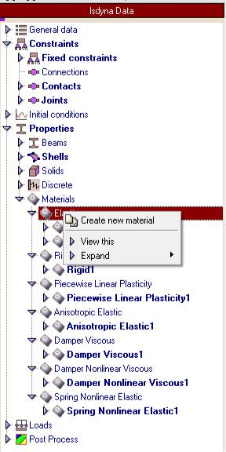

Figure 2.Materials creation
LS-DYNA Crash Tutorial 1 Page 4 of 13

To modify material properties user just have to double click material's name and edit each field like another interface group. In this case we will use Elastic1 and Rigid1 materials, but we don't need to modify its properties (we will use default values).

- To define Lower Support shell:

  - Double Click in Shells->Isotropic Shell

  - Set Thickness to 0.01 m

  - Select Elastic1 Material in material drop box

  - Click in Group command (icon placed next to drop list) and select Lower support surface form the screen (Figure 3). Press ESC after selection.

  - Change group name to Lower Support (optional)

  - Click OK to create this part

- To define Right foot:

  - Double Click in Shells->Isotropic Shell

  - Set Thickness to 0.01 m

  - Select Rigid1 Material in material drop box

  - Click in Group command (icon placed next to drop list) and select Right Foot surface form the screen (Figure 3), if render problems appears please rotate the model to solve them. Press ESC after selection.

  - Change group name to Right Foot (optional)

  - Click OK to create this part
LS-DYNA Crash Tutorial 1 Page 5 of 13
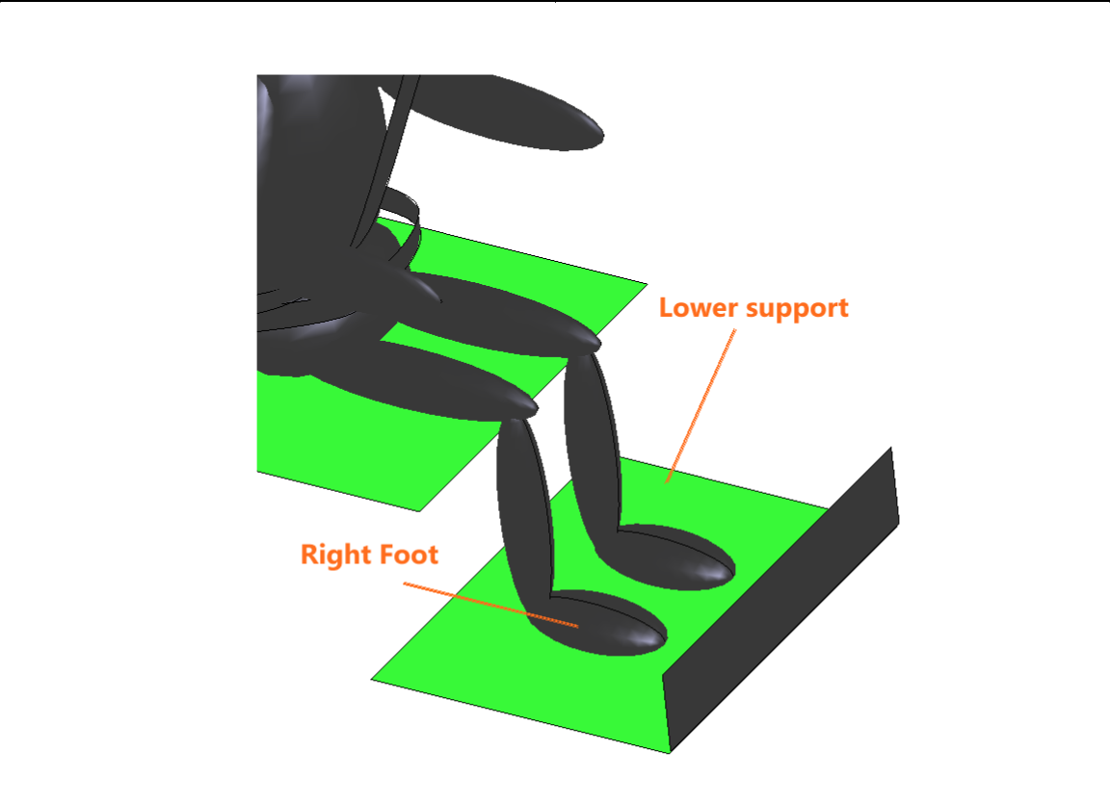

Figure 3.Model parts

- CONSTRAINTS DEFINITION

  - To represent the crash seat will suffer an important deceleration. To apply this constraint please follow these steps:

    - Double Click in Constraints->Fixed Constraints

    - In Fixation Flap, only tick Z Constraint option (acceleration will be prescribed in Z global axes direction)

    - Select Acceleration flap (left click)

    - Click to edit the acceleration behavior

      - Tick Function of time

      - From the drop list, select Interpolation function at t

      - In data entry options, verify that t units are set to s
LS-DYNA Crash Tutorial 1 Page 6 of 13

- Choose linear ramp to edit four different ramps with the parameters below (click Add at the end after each curve data introduction):

Curve 1:

  - t0: 0

  - tend: 0.001

  - Factor0: 0

  - Factorend: 0

  - Δt: 0.0001

Curve 2:

- t0: 0.002

- tend: 0.004

- Factor0: 0

- Factorend: 1

- Δt: 0.0001

Curve 3:

- t0: 0.0045

- tend: 0.006

- Factor0: 1

- Factorend: 0

- Δt: 0.0001
LS-DYNA Crash Tutorial 1 Page 7 of 13

Curve 4:

    - t0: 0.007

    - tend: 0.015

    - Factor0: 0

    - Factorend: 0

    - Δt: 0.002

  - Click Ok to close function editor

- Set az value to -15000 m/s². This factor will multiply the defined curve

- Select surface icon from the available entities.

- Click group command and select Seat surfaces (Figure 4). Press ESC after selection
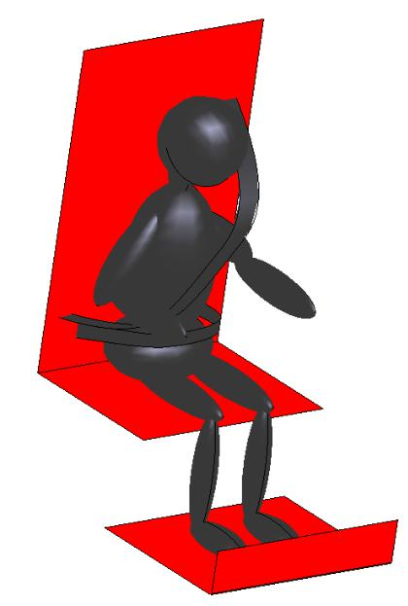

Figure 4. Seat surfaces selection

8. Name this group SeatBelt acceleration (optional)

LS-DYNA Crash Tutorial 1 Page 8 of 13

- To include seatbealt to this prescribed motion, please go to Data->Groups in GiD menu and select the group created in the last step from the list. Click

Send entities to groupto add seatbelt fixation lines (Figure 5). Press ESC after selection. Click finish and close groups editor.
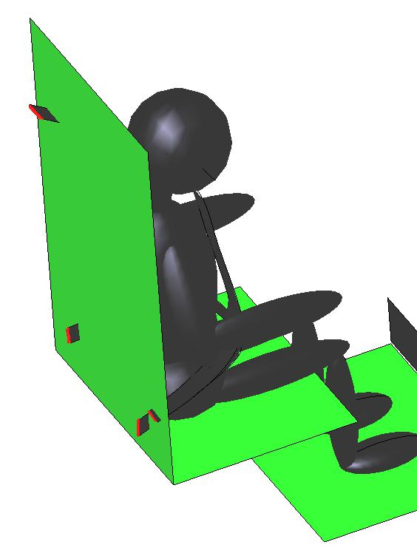

Figure 5. Seat lines selection

- Most part of contacts are already defined. The interface supports several single and master slave contacts, but in this case only Surface to Surface contact type is applied. To prescribe contact between Trunk and the Seat belt (brest) please follow next instructions:

  - In Constraints->Contacts->Control set orientation to Part and segment input

  - Double click Constraints->Contacts->Master Slave

  - Select from the available geometry entities

  - In Slave, select Seat belt brest surface with the group edition command (Figure 6)

  - In Master, select Trunk surface with the group edition command (Figure 6)
LS-DYNA Crash Tutorial 1 Page 9 of 13
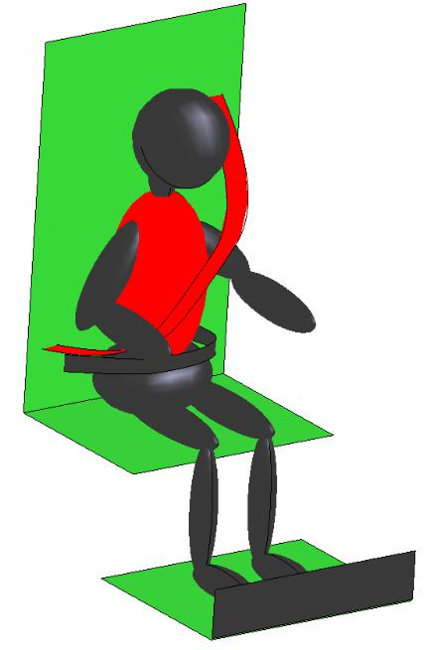

Figure 6. Involved surfaces in contact definition

  - Click OK to finish contact definition

- Most part of joints are already defined. With GiD-LSDYNA interface user can create spherical, revolute and translational joints, and define stiffness parameters. To define the joint between neck and trunk:

  - Double Click in Constraints->Joints

  - Set Relative Penalty to 0.0 and Joint Type to Spherical

  - In Point 1 Flap, introduce P1 x= - 54 m, P1 y=0, P2 z=0.2 m. Points can also be selected from the screen with:

  - Click Draw Joint Points button (placed under point coordinate labels) to draw entered point (after group creation, please press ESC on the screen to stop joint points viewing)

- Select from the available geometry entities

- In First Entity, select Neck from the drop list

- In Second Entity, select Trunk from the drop list
LS-DYNA Crash Tutorial 1 Page 10 of 13

5. INITIAL CONDITIONS DEFINITION

In Initial Conditions->All, set velocity z to 56 m/s (this initial velocity will affect all nodes)

- POSTPROCESSING OPTIONS

  - Double click in Post Process to edit GiD postprocessing options

  - Set interval to 0.001 s (at the bottom of the window)

  - Tick Write displacements, Write velocities and Write accelerations (Nodal)

  - Tick Write shell stresses and Write shell strains (Shells)

- MODEL MESHING

There many meshing options implemented in GiD software. However, in this tutorial mesh creation have been simplified as much as possible. If you want to take contact with GiD meshing capabilities please visit GiD tutorials (http://gid.cimne.upc.es/support_team/su05.html ).

- Choose Render->Normal from the mouse menu (right click)

- From GiD Menu, select Mesh->Structured->Surfaces->Assign and select seat surfaces (Figure 4). Press ESC to finish.

- Set 15 as number of cells to assign to surfaces and select seat lines in Y direction (lines will be in red). Press ESC to finish.

- Set 10 as number of cells to assign to surfaces and select seat lines in Z direction. Press ESC to finish.

- Set 20 as number of cells to assign to surfaces and select seat lines in X direction. Press ESC twice to finish.

- Choose Render→Flat from the mouse menu (right click on screen)
LS-DYNA Crash Tutorial 1 Page 11 of 13

  - From GiD Menu, select Mesh->Element type->Quadrilateral. Select Seat surfaces. Press ESC to finish.

  - From GiD Menu, select Mesh->Generate Mesh and set 2 as mesh size. Mesh generation will take few minutes.

- SIMULATION RUN

  - From GiD Menu, select Calculate->Solver Path to choose your correct solver path (it will be saved for future simulations).

  - To run the simulation, select Calculate->Calculate

3. With the button(placed in left toolbar) user can control simulation in real time

4. Wait until finish message appears (Figure 7)
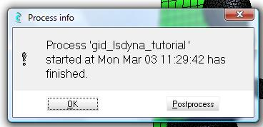

Figure 7. Finished simulation message

- RESULTS VIEW

  - When project finishes, a window appears allowing the user to analyze simulation

results (click Postprocessing button). Postprocessing results are also available by

click in toolbar icon.

  - After results load, a postprocessing interface menu will appear on the left of the screen

  - To animate the results:
LS-DYNA Crash Tutorial 1 Page 12 of 13

- Select Window->View Results from the GiD menu

- In Main Mesh Flap, tick Deformed and select nodal as Analysis type and Displacements as results (Figure 8).

- Introduce 1 in Factor Field

- Click Apply and Close

- Select Window->Animate... from the GiD menu

- Click Play Button
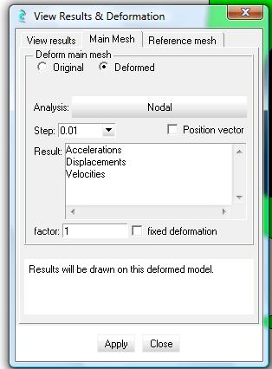

Figure 8. Main result selection

- From the postprocessing interface menu, select Analysis:Nodal->Step:0.003->Velocities->|Velocities| to study velocity contours at t=0.003 s (Figure 9)

LS-DYNA Crash Tutorial 1 Page 13 of 13
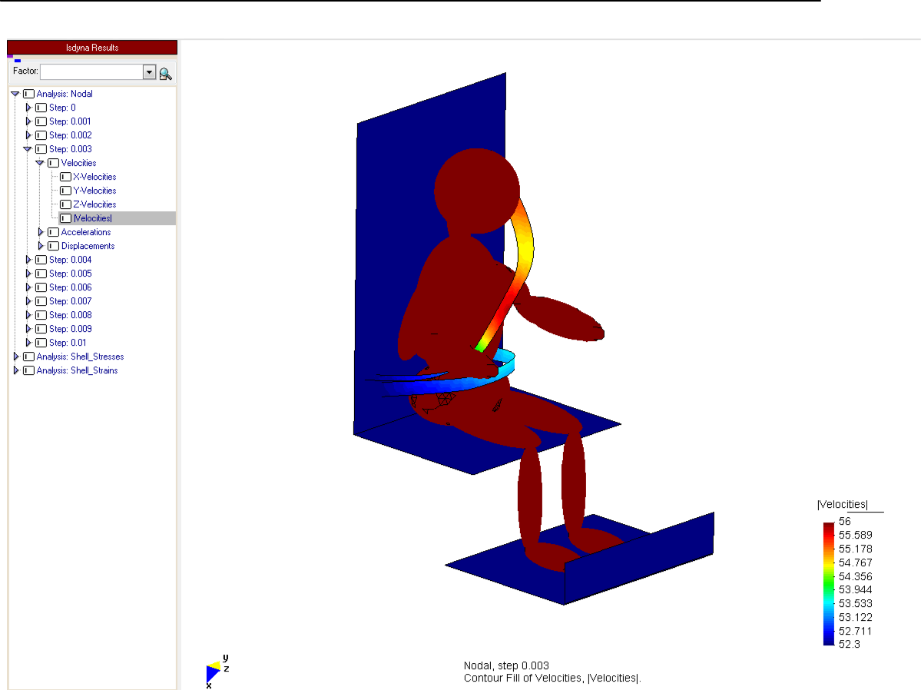

Figure 9. Velocity contour fill

